CDC Group Executive Summary

Purpose

CDC Group is implementing a centralized healthcare database to ensure secure, reliable, and interoperable management of clinical and administrative data across 54 medical centers and 60 blood collection points. The system is designed to handle 2.2 million patient interactions annually and process 3.7 million laboratory tests per year, integrating seamlessly with approximately 8000 insurance provider databases. “Databases are one of the most important components of a high-functioning healthcare organization” (Kevin Kline, 2024).

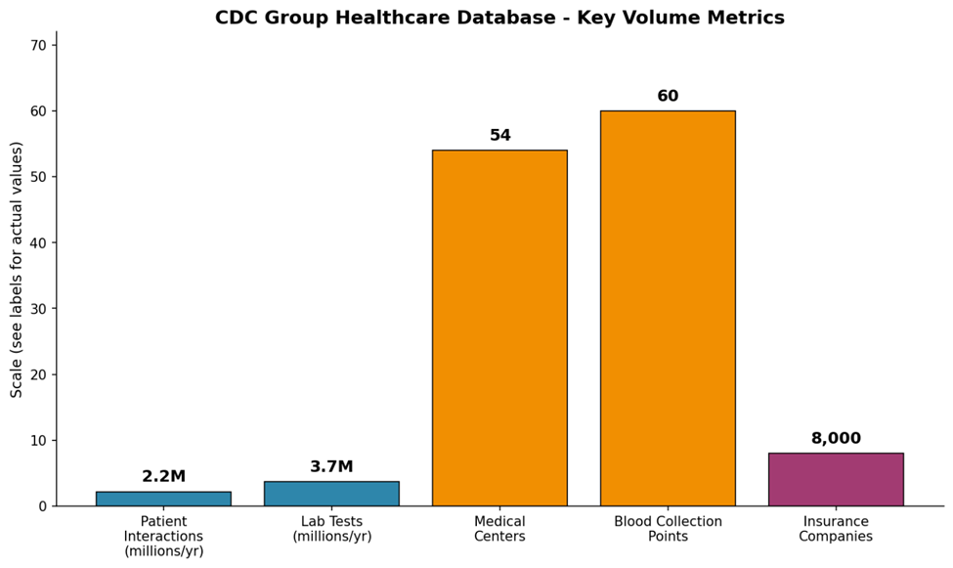
Figure 1: Key volume metrics

Logical Data Model and Core Entities
The design leverages Microsoft SQL Server, strong governance frameworks, and support for HIPAA compliance. The logical model accommodates both clinical operations and financial processes while incorporating interoperability layers (openEHR, ISO 13606) and providing consistency with scalable integration. (Openehr.org, 2025)

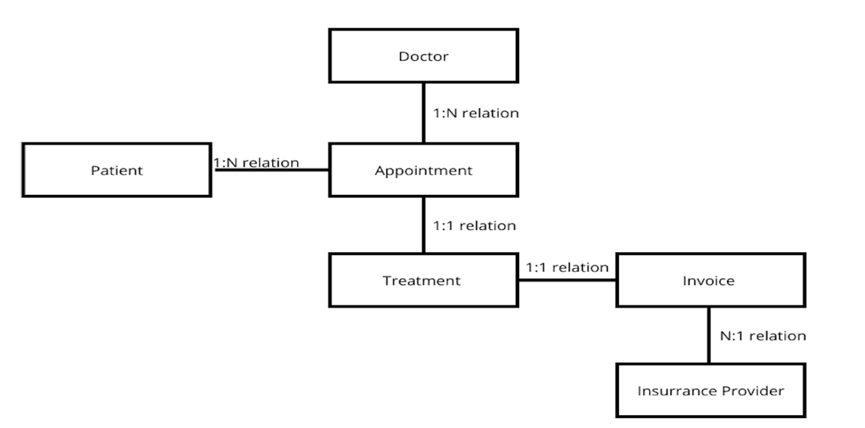
Figure 2: Relationship diagram between entities

Relationship Cardinalities
The database defines clear and logical relationship cardinalities to preserve data integrity across clinical and administrative processes. Key entity relationships include:
Patient–Appointment (1:N): Each patient can have multiple appointments, but each appointment links to only one patient.
Doctor–Appointment (1:N): A doctor may manage many appointments, while each appointment is tied to a single doctor.
Appointment–Treatment (1:1): Every appointment corresponds to exactly one treatment, ensuring accurate clinical documentation.
Treatment–Invoice (1:1): One treatment generates one invoice, supporting proper financial tracking.
Invoice–Insurance (N:1): Multiple invoices may be billed to the same insurance provider.
The schema is fully normalized and uses primary/foreign keys to enforce referential integrity across Patient, Doctor, Appointment, Treatment, Invoice, and Insurance entities. Data types such as integers, variable characters, dates, and decimals support consistency, traceability, and structured reporting.
Data Pipeline and Sources
The database ensures strong data quality and interoperability by following international standards and semantic frameworks such as openEHR, ISO 13606, and OWL. It integrates both primary and secondary data sources into a unified pipeline capable of processing 3.7 million laboratory tests annually. Primary data inputs include patient demographics, appointments, clinical documents, LIS outputs, and technician notes, while secondary sources consist of insurance provider databases and external laboratory systems. The system supports 2.2 million patient interactions per year, 3.7 million lab tests, 8,000 insurance entities, and maintains approximately 125,000 patient records. This volume highlights the need for robust, standards-driven data pipelines as the foundation for reliable healthcare analytics and operations.

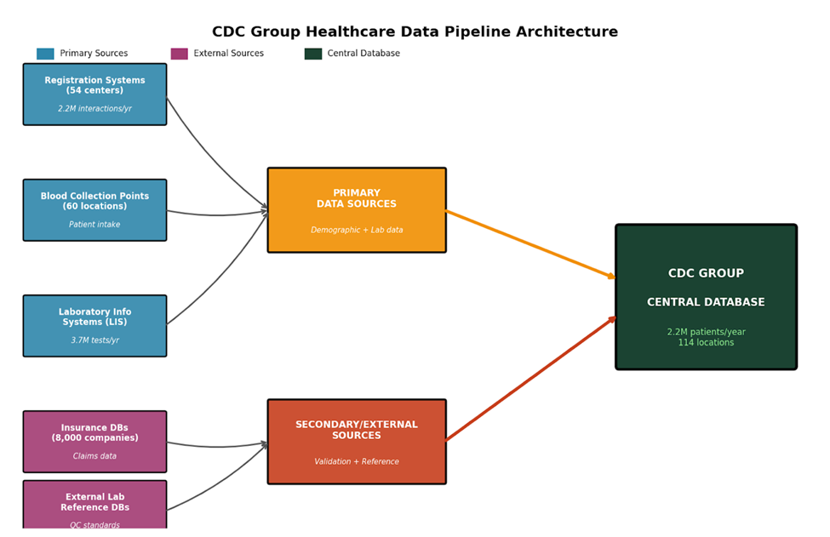
Figure 3: Data pipeline architecture
Automated data cleaning included real-time validation (Luhn algorithm, range checks), standardization (ICD-10, LOINC mapping), and duplicate detection (Jaro-Winkler metric). Security measures such as role-based access control and encryption ensured confidentiality and compliance. Future enhancements include cloud migration (Azure), AI-driven predictive analytics, mobile portals, and security audits, all aimed at improving patient engagement and operational efficiency.
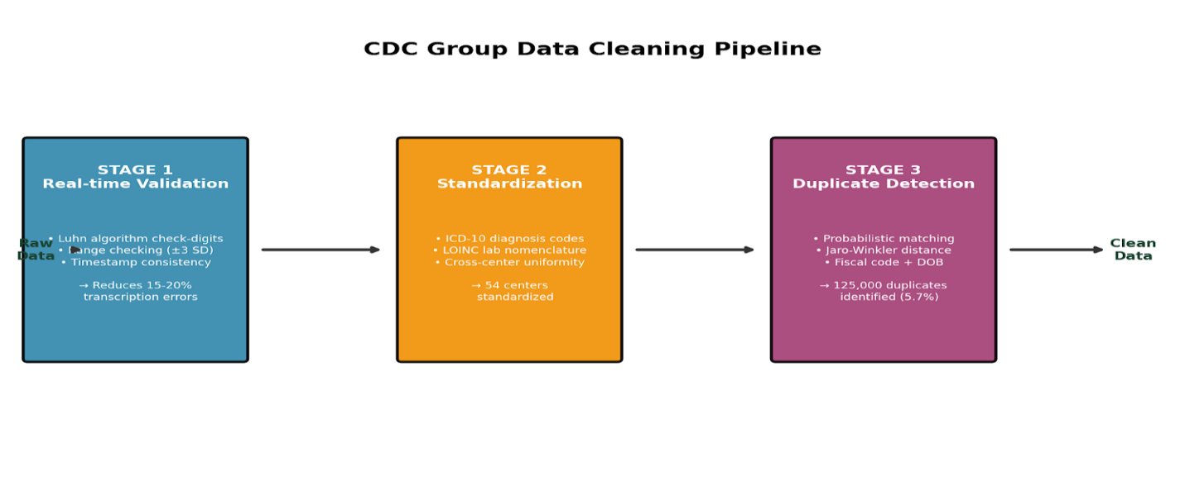
Figure 4: Data Cleaning Pipeline

Data Quality Management
For improved accuracy, fewer errors and enhanced billing integrity, CDC Group’s automated, constant quality control is essential. Real-Time Validation including check-digit validation (Luhn algorithm) for patient identifiers reducing manual transcription errors by an estimated 15–20%. Range and standard deviation checks (≥3 SD) on lab results to identify likely outliers. Consistency checks ensuring event timestamps align (e.g., test results cannot exist before specimen collection). Terminology mapping and structural Normalisation across 54 centers eliminates conflicting formats and ensures consistent analytics. Probabilistic matching was done on codes, names (Jaro-Winkler) and date of birth with an initial pass identifying 125,000 duplicates (5.7%), with processes to merge records safely while preserving origin.

Security, Privacy, and Compliance
The architecture applies in-depth defense highlighting robust compliance with HIPAA, employing role-based access control (RBAC) with least privileges and encryption via TLS with encrypted backups for service and client connections. Fixed audit retention policies, offsite encrypted backups together with retention policies aligned with regulatory guidelines guarantee a strong compliance posture.

Interoperability & Standards
To operate securely and support both day-to-day operations and across diverse systems clinical code sets were developed. ICD-10 for diagnoses, LOINC for lab observations, and DICOM for imaging. Alignment with openEHR and ISO 13606 supports flexible, standards-based composition of clinical content together with semantics to enable enhanced decision support and controlled languages to eliminate ambiguity

Analytics and Reporting
The logical design allows CDC Group to uncover descriptive, predictive and diagnostic analytics aligned with privacy and governance controls. Core reports would consist of patient output, appointments, lab tests and referrals analyses, resulting in wait-time reductions and capacity utilization.

Risks and Mitigations

RISK | MITIGATION
Duplicate records | Probabilistic matching + merge auditing
Privacy & security | RBAC, encryption, penetration testing
User adoption | Training, staged rollout, go-live support
Standards drift | Governance forums, updated mappings

TABLE 1: Risks & Mitigations

Key Performance Indicators (KPIs)

The system demonstrates strong performance across data quality, operational efficiency, and compliance. Data integrity has significantly improved, with duplicate records reduced by over 60%, 98% accuracy in ICD-10 and LOINC coding, and outlier results processed in under 4 hours. Operational outcomes show notable gains, including a 10–15% reduction in appointment no-shows, a 20% improvement in lab turnaround times, and over 95% claims acceptance. Security and compliance are robust, with no critical audit findings, 100% encryption, and all required privacy impact assessments completed.

FINDINGS

Database Design
Relational databases continue to dominate healthcare IT because they provide strong ACID guarantees needed for clinical safety and regulatory compliance (Microsoft, 2024).
Microsoft SQL Server was selected as the primary database platform due to its native integration with the Microsoft ecosystem, built-in HIPAA-aligned security, and robust governance features. Its normalized relational schema ensures data integrity, structured storage, and consistent organization across clinical and administrative systems. ANSI-compliant SQL further supports interoperability across applications.
SQL Server also provides essential compliance capabilities through role-based access control (RBAC), encryption in transit and at rest, and auditing functions. However, relational systems have limitations: modifying the schema can be complex and disruptive, and managing unstructured or semi-structured data, such as imaging, clinician notes, or sensor output, is less efficient, presenting scalability challenges for diverse healthcare datasets.

SQL vs NoSQL
Due to its strong data integrity and regulatory compliance SQL databases remain the preferred option for managing clinical and administrative healthcare data. The system provides mature built-in HIPAA-aligned features, including encryption, auditing, and role-based access control together with ANSI-standard to enable interoperability with EHRs, billing platforms and analytics tools. SQL also offers robust backup, high availability, and disaster recovery mechanisms, essential for clinical operations.
Despite these advantages, SQL databases come with certain limitations. Relational databases are less suited for unstructured or semi-structured data while the rigid, predefined schema makes structural changes costly and time-consuming.
They efficiently store semi-structured data formats such as JSON, XML, and are well-optimized for high-volume, real-time data ingestion, such as IoT medical devices and patient-generated health data. NoSQL systems present their own constraints, such as limited ACID transactions, and require additional layers of security, auditing, and governance for HIPAA compliance that are not built in by default (Health Information Privacy, 2015). Overall, SQL provides strong consistency and compliance for core healthcare data, while NoSQL complements it by supporting high-volume, flexible, and complex data scenarios

Entity-Relationship
Core entities include Patient, Doctor, Specialty, Appointment, Treatment, Invoice, and Insurance with clearly defined relationships, such as Patient–Appointment: 1: N; Appointment–Treatment: 1:1; Invoice–Insurance: N:1, for traceability and interoperability.

Standards & Interoperability
The system adheres to healthcare standards such as ICD-10, LOINC, and DICOM and implements open EHR and ISO13606 for consistency and interoperability across diverse systems.
Data Volume, Cleaning & Sources
The implementation of a comprehensive data pipeline, combined with automated data cleaning processes, addresses the challenges of handling 2.2 million patient interactions, 3.7 million lab tests, and data from 8,000 insurance providers annually. Automated validation using Luhn algorithm reduces transcription errors by 15–20%. Standardization maps diagnose ICD-10 and lab tests to LOINC codes. Duplicate detection identified 125,000 duplicate records using probabilistic matching and Jaro-Winkler metrics. Sources include EMRs, LIS, insurance databases, and external reference labs.

Security & Compliance
Organizations handling personal health data must follow GDPR requirements for privacy and data protection, while HIPAA mandates administrative, technical, and physical safeguards for PHI. When cloud providers like Azure or AWS handle PHI, they become Business Associates, requiring a signed BAA. Organizations that will be using cloud platforms and software with PHI are required to have a signed BAA in place (Dash Solutions, 2019). HIPAA compliance is further ensured through RBAC, unique user IDs, MFA, and encryption, strengthening trust and security.

GDPR
The General Data Protection Regulation (GDPR) establishes strict rules for processing personal data and mandates privacy, meaning data protection controls must be integrated into systems and workflows from the outset. The General Data Protection Regulation (GDPR) is the toughest privacy and security law in the world (Wolford, 2025) Organizations must define clear data retention periods and ensure timely, secure deletion of data that is no longer needed. organizations must define clear data retention periods and ensure timely, secure deletion of data that is no longer needed. In the event of a personal data breach, organizations are obligated to follow a strict breach notification process, informing supervisory authorities within 72 hours of becoming aware of the incident. Finally, any transfers of personal data outside the EU/EEA must be protected using approved mechanisms such as Standard Contractual Clauses (SCCs) or transfers to countries recognized through adequacy decisions.

HIPAA
Organizations handling Protected Health Information (PHI) must comply with HIPAA by implementing strong administrative, technical, and physical safeguards. HIPAA Compliance is crucial for businesses that handle Protected Health Information (PHI) (Lueilwitz, 2024). A key requirement is role-based access control (RBAC) with unique user identifiers, ensuring staff access only the minimum necessary PHI for their duties. Access must also be protected with multi-factor authentication (MFA).
HIPAA mandates robust data protection, including encryption of PHI at rest and in transit using properly managed encryption keys. When using cloud services such as Azure or AWS, organizations must secure Business Associate Agreements (BAAs) and ensure only HIPAA-eligible services are used.
Additionally, organizations must perform regular risk analyses, provide ongoing workforce training, and maintain backup, redundancy, and disaster recovery procedures to ensure continuity and safeguard PHI during failures or emergencies.
ISO 27001 & 27701
Adopting ISO/IEC 27001:2022 for information security and ISO/IEC 27701:2025 for privacy governance establishes a unified, auditable framework for managing security and data protection requirements. ISO/IEC 27001 specifies the requirements for establishing, implementing, maintaining, and continually improving an information security management system (Bsigroup.com, 2013). SO/IEC 27701:2025 extends ISO 27001 and 27002 to include privacy governance and data protection controls, creating a Privacy Information Management System (PIMS).

RECOMMENDATIONS

Cloud Migration
Switching the database to secure cloud environments like Azure or Google Cloud SQL would improve scalability, disaster recovery, and cost efficiency, while guaranteeing HIPAA-compliance configurations throughout the migration process.

Advanced Analytics & AI Integration
Employ predictive analytics for early disease detection and resource optimization using AI-driven insights for enhanced clinical decision making and patient outcome forecasting.

Mobile and Patient Portal Development
Mobile applications and web portals using multi-factor authentication would allow patients to access records, schedule appointments, and view test results.

Data Governance
Establish a centralized data governance framework to monitor compliance, enforce standards, and manage data lifecycle.
Regularly update mappings for ICD-10 and LOINC codes to maintain interoperability.

Audits & Constant Monitoring
Conducting security audits combined with penetration testing to identify vulnerabilities.
In addition, implementing real-time monitoring tools for detection of unauthorized access.

Interoperability Expansion
Using HL7 and FHIR standards would strengthen integration with other external healthcare systems and insurance providers while health initiatives can be supported by exploring partnerships for data exchange.

Conclusion
The CDC Group’s centralized healthcare database unifies clinical, administrative, and financial data across 54 medical centers, 60 blood collection sites, and numerous insurance partners, supporting over two million patient interactions each year. Built on Microsoft SQL Server, the logical data model ensures strong data integrity and seamless integration with EMR, LIS, PACS, and analytics platforms. The system adheres to major regulatory and security standards, including HIPAA, GDPR, ISO/IEC 27001:2022, and ISO/IEC 27701:2025. Planned enhancements, such as cloud migration, mobile patient portals, AI-driven analytics, and expanded interoperability, will further strengthen resilience, compliance, and service quality across the healthcare ecosystem.

REFERENCES
Kevin Kline (2024). The Top Three Reasons Why Secure, Reliable Databases Are Essential for Modern Healthcare Organizations. [online] Database Trends and Applications. Available at: https://www.dbta.com/Editorial/Think-About-It/The-Top-Three-Reasons-Why-Secure-Reliable-Databases-Are-Essential-for-Modern-Healthcare-Organizations-166228.aspx
Openehr.org. (2025). openehr.org – The future of digital health is open. [online] Available at: https://www.openehr.org [Accessed 18 Jan. 2026].
Databahn.ai. (2025). Building a Foundation for Healthcare AI: Why Strong Data Pipelines Matter More than Models - DataBahn. [online] Available at: https://www.databahn.ai/blog/building-a-foundation-for-healthcare-ai-why-strong-data-pipelines-matter-more-than-models [Accessed 18 Jan. 2026].
Microsoft (2024) SQL Server security and compliance documentation. Microsoft Learn. Available at: https://learn.microsoft.com/sql/sql-server (Accessed: 18 January 2026).
Wolford, B. (2025). What is GDPR, the eu’s new data protection law? [online] GDPR.EU. Available at: https://gdpr.eu/what-is-gdpr/.
Health Information Privacy (2015). Health Information Privacy. [online] HHS.gov. Available at: https://www.hhs.gov/hipaa.
Lueilwitz, A. (2024). HIPAA Quotes on Healthcare Data Security and Confidentiality. [online] CGAA. Available at: https://www.cgaa.org/article/hipaa-quotes [Accessed 19 Jan. 2026].
Dash Solutions. (2019). What Is A HIPAA Business Associates Agreement (BAA)? | Dash Solutions. [online] Available at: https://www.dashsdk.com/resource/what-is-a-hipaa-business-associate-agreement-baa/.
Bsigroup.com. (2013). BS EN ISO/IEC 27001:2017 | 1 Oct 2013 | BSI Knowledge. [online] Available at: https://knowledge.bsigroup.com/products/information-technology-security-techniques-information-security-management-systems-requirements-1 [Accessed 18 Jan. 2026].

